Name: Shubham Rawat
Course: MCA
Batch: 2020 – 2021
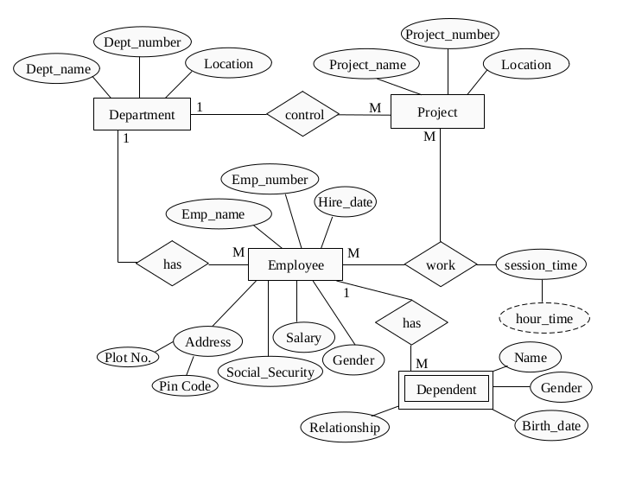
has
Emp_number
Project_number
Dept_number

